WAGNER SOCIETY OF IRELAND NEWSLETTER SUMMER 2017

Dear Member,

As we come to the end of our talks for 2016-17 I would like to thank our excellent speakers. We are looking forward to our trip to Prague/Budapest in June and are anxious for suggestions as to future trips. As most of you know there is an additional trip in November to Berlin. If interested ring Anthony immediately please.
We wish you all an enjoyable Summer and we look forward to hearing of your operatic exploits when we meet in the Autumn.
The Committee.

THERE WAS NO SWAN!

There was no swan but when have we last seen a swan in Lohengrin? There were, however, a handful of feathers and a young boy who crossed the stage at intervals wearing one wing.

This was Lohengrin at the Opera Bastille, Paris, in January 2017, directed by Claus Guth. This production had opened the La Scala season in 2012 with many of the same cast and was to be seen in cinemas at that time. Claus Guth is known for his psychoanalysis of his characters. His Fidelio for Salzburg in 2015 was based on the premise that the imprisonment and torture of Floristan was all in his mind.

As well as the lack of a swan, there was no heroic saviour either. This Lohengrin was a trembling wreck. We first see him, as the chorus parts, curled up on the ground with his back to the audience and in the throes of convulsions. He assumed the same position at the end of the opera. He was casually dressed and bare-foot except for his wedding. He was disorientated, startled by the world around him and by the sound of the chorus and especially the trumpets. At times he seemed bemused by the attention he was getting but he certainly gave no indication that he could lead the men of Brabant into battle.

Set and costumes (by Christian Schmidt) were updated to the mid-19th century, the time of composition. The single set, covering three sides of the stage, was a dull three-tiered barrack-like building with many doors and windows which formed a court-yard and was transformed for the post-wedding scene into woodland with a pond. The women’s costumes are all black, including the bridesmaids, while Elsa was dressed in full bridal white. The wedding guests, ranged on the top tier of the set, wore top hats and tails, as did the bridegroom. There was little by way of props: a large table was moved on and off stage as required and there was a piano stage left which both Elsa and Lohengrin sat at on occasions. It was upturned for the last Act. The piano appeared to suggest that Ortrud was Elsa’s piano teacher and a lesson was re-enacted where the piano lid was banged closed on Elsa’s hands, presumably to demonstrate an abusive relationship. To add to the confusion, there were a boy and girl representing the young Elsa and her brother who appeared to act out some episodes from the past. Also the young boy with the wing would appear on the balcony whenever Elsa thought of her brother.

Lohengrin in Opera Bastille was the most sought after ticket in Paris last January. It marked the return to performance of Jonas Kaufmann after a prolonged absence due to illness and also the first occasion on which Philip Jordan conducted Lohengrin, although he had already conducted many other Wagner operas. While some critics felt that Jonas Kaufmann’s singing was somewhat tentative on opening night (18 Jan), by the third performance which I attended (27 Jan) he was very much in command. He enacted Guth’s concept with extraordinary attention to detail and embodied the lost hero who had wandered into a strange place. His rendering of the Grail Narration was the high point of the evening. On a darkened stage with just a spotlight on him and another on Elsa, he told his story in hushed tones as if he was explaining it to himself rather than to the assembled court. It was spell-binding.
The other singers all acquitted themselves satisfactorily in their various roles. Edith Haller as Elsa epitomised a girl/child, full of dreams and imaginings but also given to fainting fits. She coped admirably with the change from showing sympathy to Ortrud to a petulant young lady demanding an answer to the forbidden question. Ortrud, sung by Evelyn Herlitzius, was the personification of evil in every note, look and gesture. Talramund, sung by the baritone Thomasz Konieczny, was somewhat colourless but a perfect foil to Ortrud’s hysterics. Rene Pape brought majesty and elegance to the role of King Henry with every note he sang.

The orchestra were at their finest and Philip Jordan’s reading of the score drew attention to elements that Wagner would develop in his later operas. The chorus, which is an additional character in this opera, was magnificent in sound and movement.

So, while the production was somewhat puzzling, imposing on Lohengrin character traits that were at odds with the music, the high musical and dramatic values made is a very satisfactory night at the opera.

Mary Spollen

Maeve and I went to a performance with the alternative cast in February. Stuart Skelton was very good as Lohengrin. A large man he was not very mobile and found the acting involved in this Claus Guth production taxing. His singing was very fine. MARTINA SERAFIN was very believable as Elsa but the star of the evening was MICHAELA SCHUSTER as Ortrud. Spellbinding she was electric and ran the show.
Most certainly a production to see.

PAUL MAGNIER

DIE MEISTERSINGER VON NURNBERG MARCH 2017
ROYAL OPERA HOUSE, COVENT GARDEN

CONDUCTOR Antonio Pappano
DIRECTOR Kaspar Holten
This was Kaspar Holten’s last production at Covent Garden as Director of Opera there.
He prefaces the synopsis in the programme book with the following:
“Kinder, Schafft Neues” (Children, create new things!)
Richard Wagner 1852 and Walther writes this on the the set during the opera.
Act 1 takes place in a London club and the opening chorale is a chorus practicing, with Hans Sachs monitoring things at the front of the stage. When the masters arrive they are accompanied by their wives elaborately dressed who then leave (It’s a men only club). The masters are then served dinner and the whole scene is frenetic and fussy.

The club setting is very elaborate and is also used for Act 2. There is a complete failure to create any kind of athmosphere and Sachs, for example, works on the shoes at one of the tables used for dinner in Act 1. The riot is imagined by Sachs (I think?)

Act 3 is not much better and the finale takes place in a theatre in the club. Eva is so taken aback by the outcome of the song contest and the male domination that she runs horrified from the scene.
Musically the evening was terrific and the detail in the playing was superb. The principals were as follows.

HANS SACHS Bryn Terfel
WALTHER Gwyn Hughes Jones
MAGDALENE Hanna Hipp
DAVID Allan Clayton
POGNER Stephen Milling
BECKMESSER Johannes Martin Kranzle
EVA Rachel Willis-Sorensen

The standouts for me were Terfel and Kranzle. Kranzle is due to sing Beckmesser in the new Meistersinger in Bayreuth this Summer.

JAMES MCLOUGHLIN

I attended this production and agree with James as to the outstanding Antonio Pappano and his ROH orchestra.
I thought Bryn Terfel was not at his best and he did not sing Act 3 at a later performance. Interesting that he is not to sing Wotan in the ROH Ring Cycle in Autumn 2018.
The stand-outs for me were JOHANNES MARTIN KRANZLE and STEPHEN MILLING. DAVID SHIPLEY was excellent as the Nightwatchman and will go far.
Definitely a G.B.Shaw evening-close your eyes and listen to the music.

PAUL MAGNIER

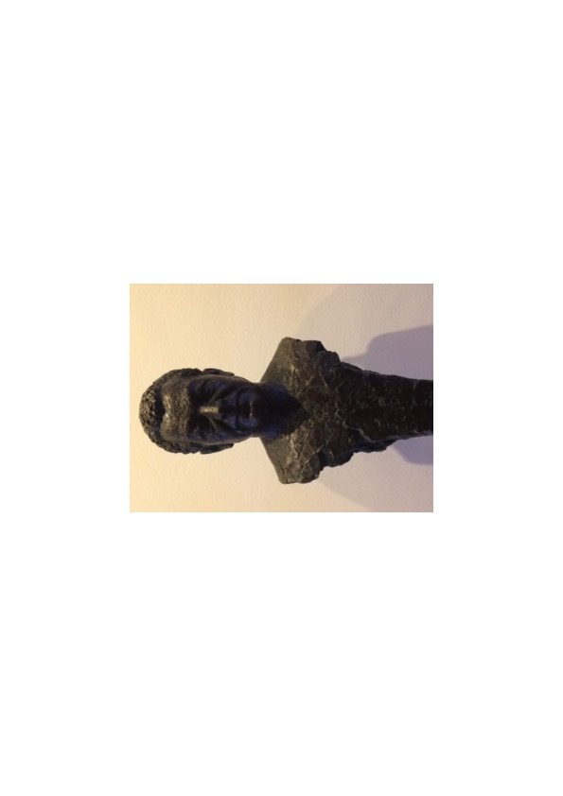Gotz Friedrich Bust Deutsche Oper Berlin

Der Ring des Nibelungen
Gotz Friedrich Ring Cycle – Deutsche Oper Berlin

I attended the final performance of this Gotz Friedrich Ring cycle at the Deutsche Oper Berlin from April 13th – 17th 2017.
This Ring cycle was first staged in Berlin in 1984 and 1985 and has been performed in its entirety on 48 occasions since, in addition to two cycles in Japan in 1987 and two cycles in Washington DC in 1989.
It is quoted that Gotz Friedrich said that a friend sent him a postcard of a Washington subway station with a spacious cylinder type architecture which gave him the idea of setting the cycle underground with the ghosts of the gods and their antagonists doomed to replay their tragedy over and over again, banished from the earth above which was likely scorched by nuclear arms.
Hence it is often referred to as the “tunnel ring” or by some British Wagnerites as the “tube ring” because it also resembles the London underground.

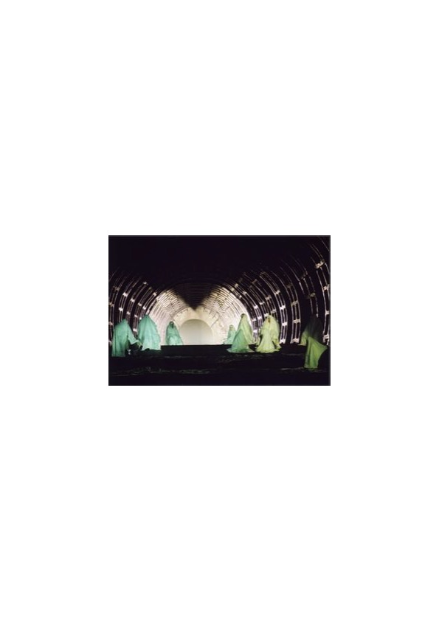
Fig 1: Opening scene of Das Rheingold

Das Rheingold.

The set was dominated by a large tunnel which spanned the entire stage width and which appeared to extend forever to the back of the very deep stage of the Deutsche Oper. At the opening scene the gods were cloaked in white and were standing like statues in the tunnel (Fig 1) and the Rhinemaiden scene was achieved using curtains which moved. The Nibelheim was shown by elevating the main stage floor and the scene took place underneath, crammed with steel pipes, ducts, gadgets and bright lights. A curtain was placed at the end of the tunnel onto which was projected a rocky landscape with Valhalla above it.

The young Australian Baritone, Derek Welton, who having become a member of the Deutsche oper company in 2016, made his role debut as Wotan during these Ring performances. He has a strong voice and sang and acted the part well.
Alberich was well sung by bass-baritone Werner van Mechelen as was the role of Mime by Paul Kaufmann. Buckhard Ulrich sang the role of Loge and though he acted well I felt his voice did not suit the part.
Albert Pesendorfer as Fasolt and Andrew Harris as Fafner were satisfactory as were Attilio Glaser as Froh and Noel Bouley as Donner.
Daniela Sindram was a faultless Fricka.
The Rhinemaidens, Meechot Marrero, Christina Sidak and Anniota Schlicht sang and acted well as did Martina Welschenbach as Freia.
Erda, sung admirably by the American Ronnita Miller appeared from the very back of the tunnel and walked slowly towards the front as she sang her warning to Wotan to yield the ring to the giants.

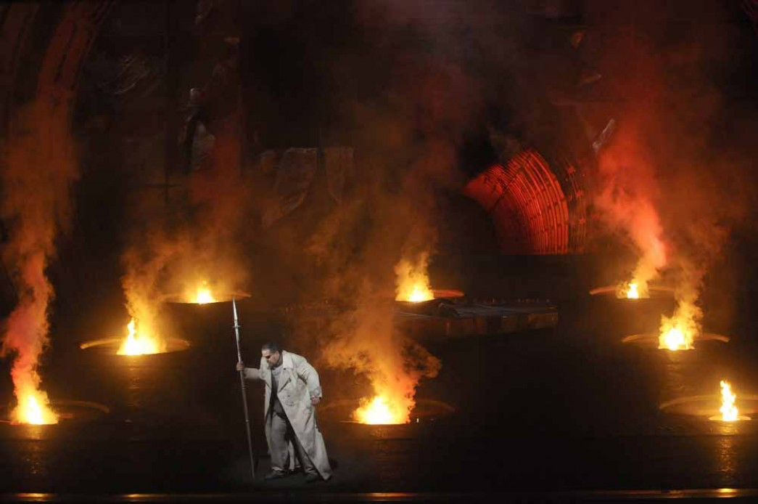

Fig 2: Final scene of Die Walkure

Die Walkure.

Act 1 of Die Walkure took place at the front of the stage with a table, some chairs and the world ash tree towards the centre. It was separated from the remainder of the tunnel by a wall which later in the act opened up, to show a tunnel filled with vegetation through which the twins escaped. The visual effects at the end of the final act were really impressive (see Fig 2). Eight fire traps opened in succession engulfing the entire stage in smoke which was accompanied by stunning lighting effects.
Stuart Skelton sang the role of Siegmund and Eva Maria Westroek the role of Sieglinde – and what a performance – both sang and acted excellently. Tobias Kehrer, surrounded by uniformed guards, was an intimidating and excellent Hunding.
The Valkyries were excellent , looking like Hell’s Angels in their leather attire, gathered in a circle to protect Brunnhilde and putting up a significant fight when Wotan advanced.
As in Das Rhinegold Daniela Sindram repeated her excellent performance as Fricka. Ian Paterson as Wotan was satisfactory. His acting was excellent but for me his voice does not suit the role of Wotan.
This is the third time I have seen Evelyn Herlitzius perform the role of Brunnhilde and on this occasion she gave her customary committed and athletic performance, but her voice was not as smooth as on previous occasions and it was difficult at times to hear her lower register (she may be singing too many Elektra’s !).

Siegfried.

Act 1 took place at the front of the stage. The forge was to the right and as in the Nibelheim was located beneath the main stage floor. Mime’s hut was to the left with tables and chairs in front of a curtain displaying colourful forest scenes.
In Act 2 the front and middle of the stage was covered in forest vegetation and a large mechanical device representing the dragon occupied the rear of the stage.
In Act 3 the stage floor was again raised to reveal Erda at lower ground level. The scene between Siegfried and the Wanderer took place at the ground level and the awakening of Brunnhilde and the love duet took place in the tunnel.
Stefan Vinke as Siegfried mounted all the challenges of this difficult role, giving a tireless performance. Ricarda Merbeth as Brunnhilde also gave a great performance and Samuel Youn as the wanderer gave a fine performance.
Buckhard Ulrich was an excellent Mime, both in terms of his acting and his singing and performed much better in this role than he did earlier in the role of Loge. Ronnita Miller was again a convincing Erda. Werner van Mechelan as Alberich and Andrew Harris as Fafner both performed their roles well, as did Elbenita Kaftazi as the woodbird.

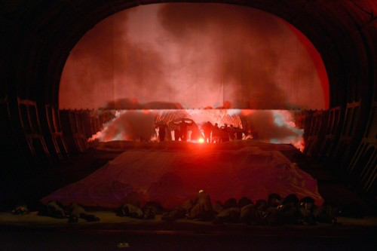
Fig 3: Destruction of Valhalla

Gotterdammerung.

The full tunnel was present during this entire opera. The opening scene with the 3 Norns spinning the rope of knowledge was effective though darkly lit. The Gibichung Hall was achieved with the clever use of columns and mirrors. At the end Valhalla went up in flames with very effective special illumination effects along the length and width of the tunnel (Fig 3).
Evelyn Herlitzius again sang the role of Brunnhilde . She gave an intense athletic performance and was magnificant in the second and final acts. Stefan Vinke returned to sing the role of Siegfried and tirelessly got through the demands imposed on him by the composer. He portrayed the character of an arrogant and flawed youg hero well. Albert Pesendorfer sang an excellent Hagen and was manipulative and coldly calculating in the role. (Matti Salminen, who sang the role of Hagen on 34 occasions in this productions history sat in the audience, 3 rows in front of me and slightly to my left. He seemed to re-live every moment of the role, raising his right hand on every occasion Hagen was about to sing, as if conducting.)
Daniela Sindram was an exceptional Waltraute and in the first act she also sang the 2nd Norn. Ricarda Merbeth was an excellent Gutrune and Seth Carico was an accomplished Gunther with good acting skills.
Werner van Mechelen was a satisfactory Alberich. The Norns and Rhinemaidens wer excellent. The Deutsche Oper Chorus was outstanding.

The Orchestra of the Deutsche Oper was conducted by its musical director, Donald Runnicles. He is an excellent conductor and under his direction the orchestra played superbly throughout. His approach was never showy but he can whip up the orchestra when necessary as he did at the eruption of fire during the destruction of Valhalla. In general he was always rock solid, and was supportive of the singers allowing them to carry the drama.

The Deutsche Oper was sold out for all performances and the audience gave an enthusiastic reception to all the artists at the end of each night. On the final evening Donald Runnicles took his bow on stage alongside the Deutsche Oper orchestra where they received a well earned standing ovation.

Overall, this was a production which told the story in a straightforward and clear manner. Combined with excellent orchestral playing it was a superb experience.

The Deutsche Oper have comissioned a new Ring Cycle by the Director Stefan Herheim – a former pupil of Gotz Friedrich. Das Rhinegold will appear in 2020.

VERONICA DONOGHUE

WAGNER OPERA PERFORMANCES 2017-18 SEASON

TANNHAUSER

DEUTSCHE OPER: NOV 9/12 DEC 2 APRIL 2/8
LEIPZIG: MAR 17/24 APR 2 MAY 17
TALLINN: NOV 9/11 MAY: 10/30

LOHENGRIN

BRUSSELS: APRIL 19/20/22/24/26/27/29 MAY 2/4/6
ERL: 2017 JULY 8/29 2017
DEUTSCHE OPER: NOV 9/12 DEC 17
MARSEILLE: MAY 2/5/8
PRAGUE: SEPT 2/23 FEB 18 MARCH 11 MAY 26 JUNE 10
VIENNA: JUNE 15/18/22/26

DER FLIEGENDE HOLLANDER

BADEN-BADEN: MAY 18
DEUTSCHE OPER: SEPT 8/22/27 OCT 18
DRESDEN: FEBRUARY 11/15/18/23 JUNE 29 JULY 2
ENSCHEDE: APRIL 20
HAMBURG: FEBRUARY 13/16/21/24 MARCH 2
MUNICH: JUNE 29
TALLINN: SEPTEMBER 14/17 OCTOBER 12 FEBRUARY 14/16
ZURICH: MARCH 21/24/28/31

TRISTAN UND ISOLDE

AMSTERDAM: JAN 18/22/25 FEB 4/7/10/14
BARCELONA: NOV 27 DEC 2/4/7/10/12/15

RING CYCLE

ERL: 13/14/15/16 JULY 2017
DRESDEN: (1) JANUARY 13/14/18/20
(2) JANUARY 29/30/FEBRUARY 1 / 4
LEIPZIG: (1) JANUARY 6/7/13/14
(2) APRIL 11/12/14/15
(3) MAY 10/11/12/13
MUNICH (1) JANUARY 11/19/31/FEBRUARY 8
(2) JANUARY 13/22/FEBRUARY 3/11
(3) JULY 20/22/24/27
VIENNA APRIL 4/8/11/15

DAS RHEINGOLD

HAMBURG: MAY 18/21/26/29
FRANKFURT: APRIL 13/19/22 MAY 1/6

WALKURE
TOULOUSE: FEB 2/6/9/11
HAMBURG: JAN 7/14/20

SIEGFRIED
OVIEDO: SEPT 6/9/13/16

GOTTERDAMMERUNG

DRESDEN: OCT 29 NOV 1/5

PARSIFAL

BADEN-BADEN: MARCH 30 APRIL 2
HAMBURG: SEPTEMBER 16/24/27/30/ OCTOBER 3
MUNICH: JUNE 28/JULY 1/5/8/31
PARIS: APRIL 27/30 MAY 5/10/13/16/20/23
VIENNA: MARCH 28 /APRIL 1/5
ZURICH: FEBRUARY 25 MARCH 3/7/10

RECENT BOOKS OF INTEREST TO WAGNERIANS

THE RING OF TRUTH: THE WISDOM OF WAGNER’S RING
RICHARD SCRUTON
Allen Lane London 2016 ISBN 978-0-241-18855
An English philosopher who argues the case for delineation of character though the music in the Ring without the need for outlandish productions. Very persuasive.

RICHARD WAGNER IN DER ZEITGENOSSISCHEN FOTOGRAFIE
GUNTHER BRAAM €39
ConBrio: Regensburg 2015 ISBN:978-3-940768-44-5
A catalogue of all known photographs of Wagner. Impressive.

MY LIFE WITH WAGNER
CHRISTIAN THIELMANN
Weidenfield & Nicolson London 2015 ISBN 978-0-297-60855-4 £25
Of interest but rather disjointed.

STOP PRESS
Membership numbers are slipping.
The committee would like members to mention/cajole/suggest joining to their musical friends.

I am keen to extend the number of members who write for the Newsletter. Please send me any reports/opinions/controversies/suggestions on Wagner and his work at tpmagnier@gmail.com

PAUL MAGNIER

